NOTE TO ORGANIZERS: THIS GUIDE IS A SUGGESTED TEMPLATE MADE BY HACK CLUB HQ FOR ALL HAVEN EVENTS. PLEASE DO NOT PUBLISH IT WITHOUT REVIEWING ALL COMMITMENTS MADE IN THIS GUIDE AND MAKING SURE THAT THEY ARE ACCURATE FOR YOUR EVENT. IF YOU HAVE ANY QUESTIONS, PLEASE CONTACT YOUR EVENT MANAGER.

A Parent’s Guide to Hack Club Haven [City]

Outline
- What is Hack Club?
- What is Haven?
- Expenses & Meals
- Traveling to [Venue]
- Safety Arrangements
- Key Personnel
- Contact Information

What is Hack Club?
Hack Club is a 501(c)(3) nonprofit organization, founded in 2014, with the mission of fostering an empowered generation of coders, leaders, and innovators. “Hacking” is being constructively redefined as a means of creative coding—apps, games, websites etc. Through our global network of student-led computer science clubs, over 100K+ teenagers engage with our programs annually.

All of Hack Club’s programs are free and universally accessible. We’re supported by
GitHub founder Tom Preston-Werner, Dell founder Michael Dell, SpaceX’s Gwynne Shotwell, executives at Apple and Microsoft, and many up and coming startups as well.

Every year, Hack Club runs a few transformative events for teenagers interested in
technology. In the past, we’ve chartered a train across Canada, ran hackathons in San Francisco & New Delhi, ran a 4-day hackathon on an island, and sent out $50,000 in hardware grants.
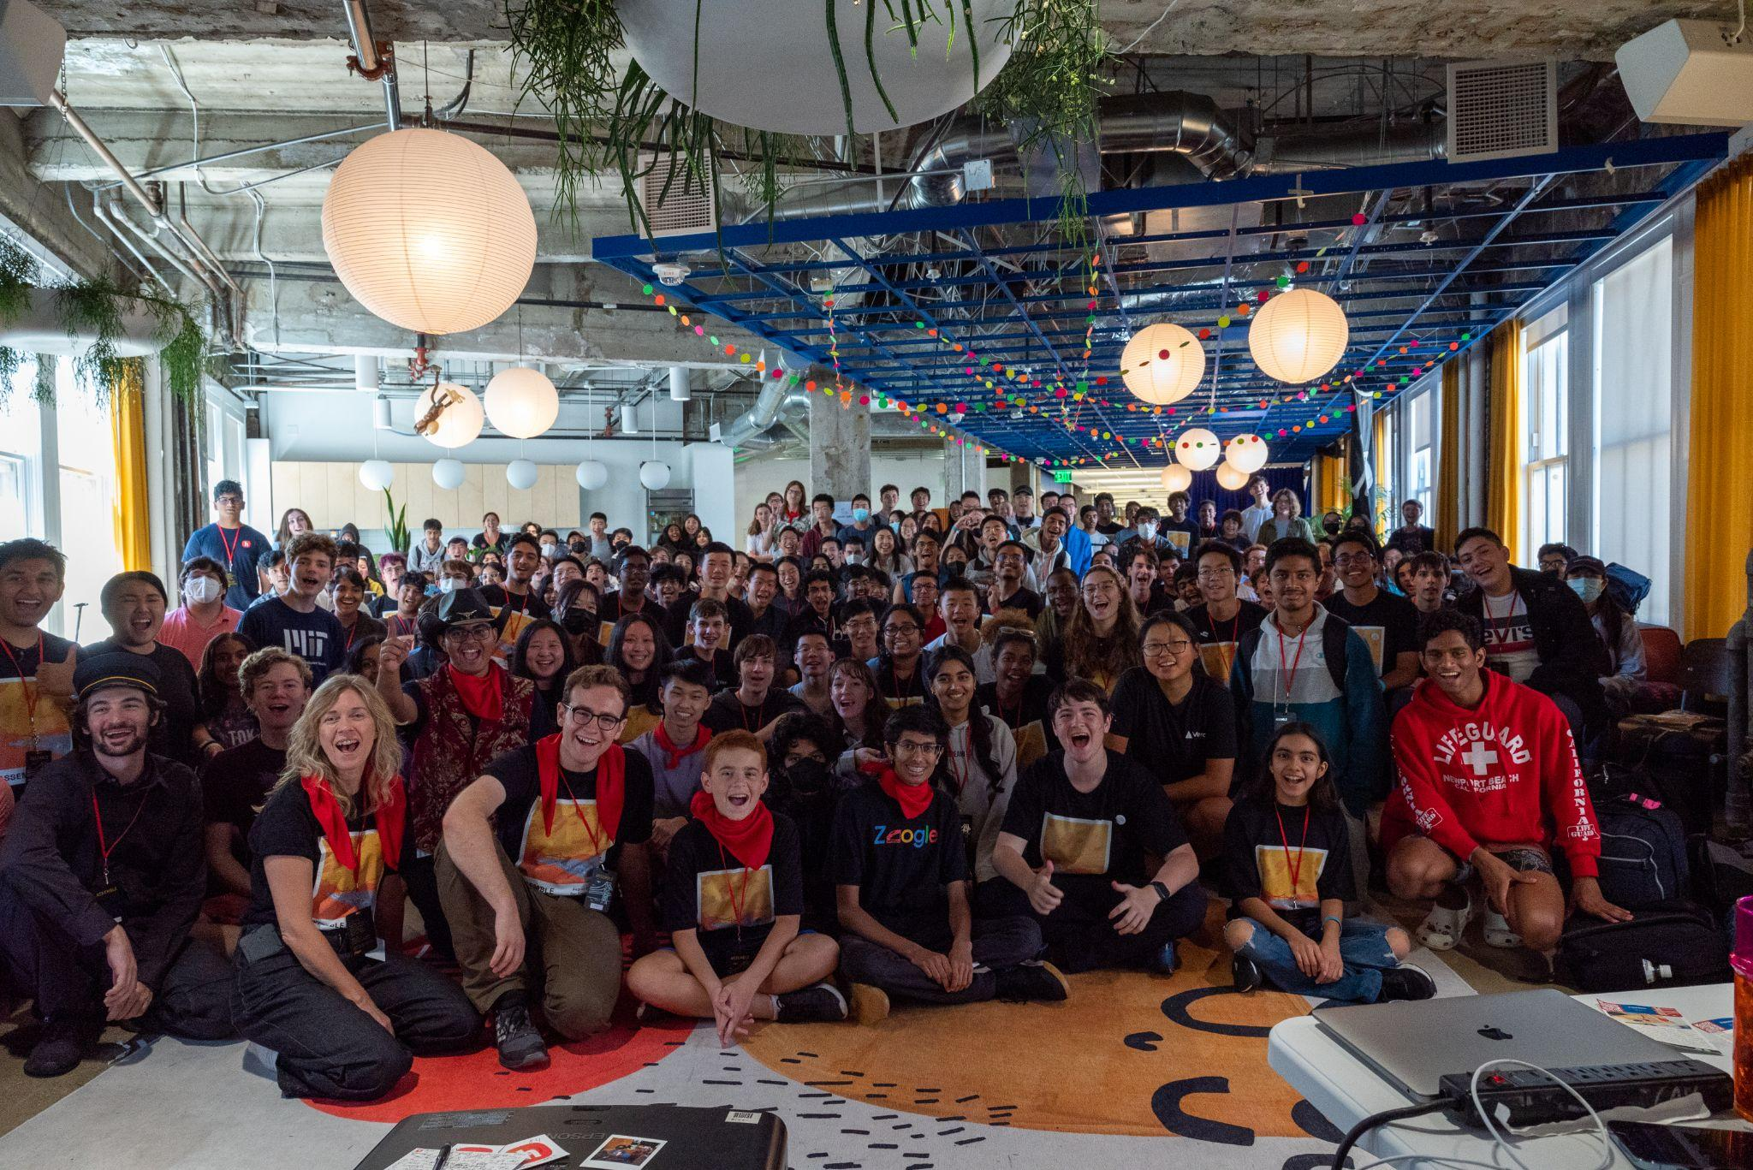  Assemble, San Francisco | 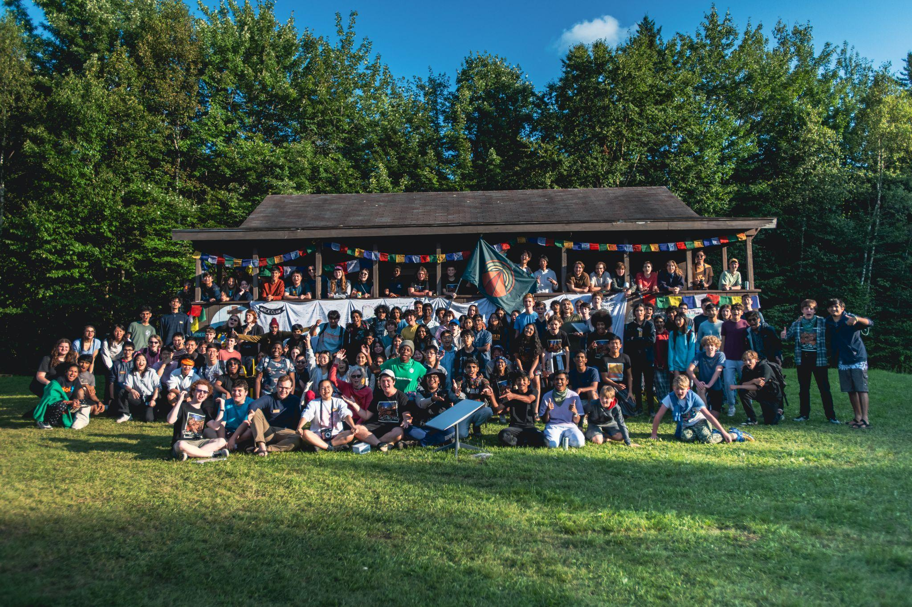  Outernet, Vermont | 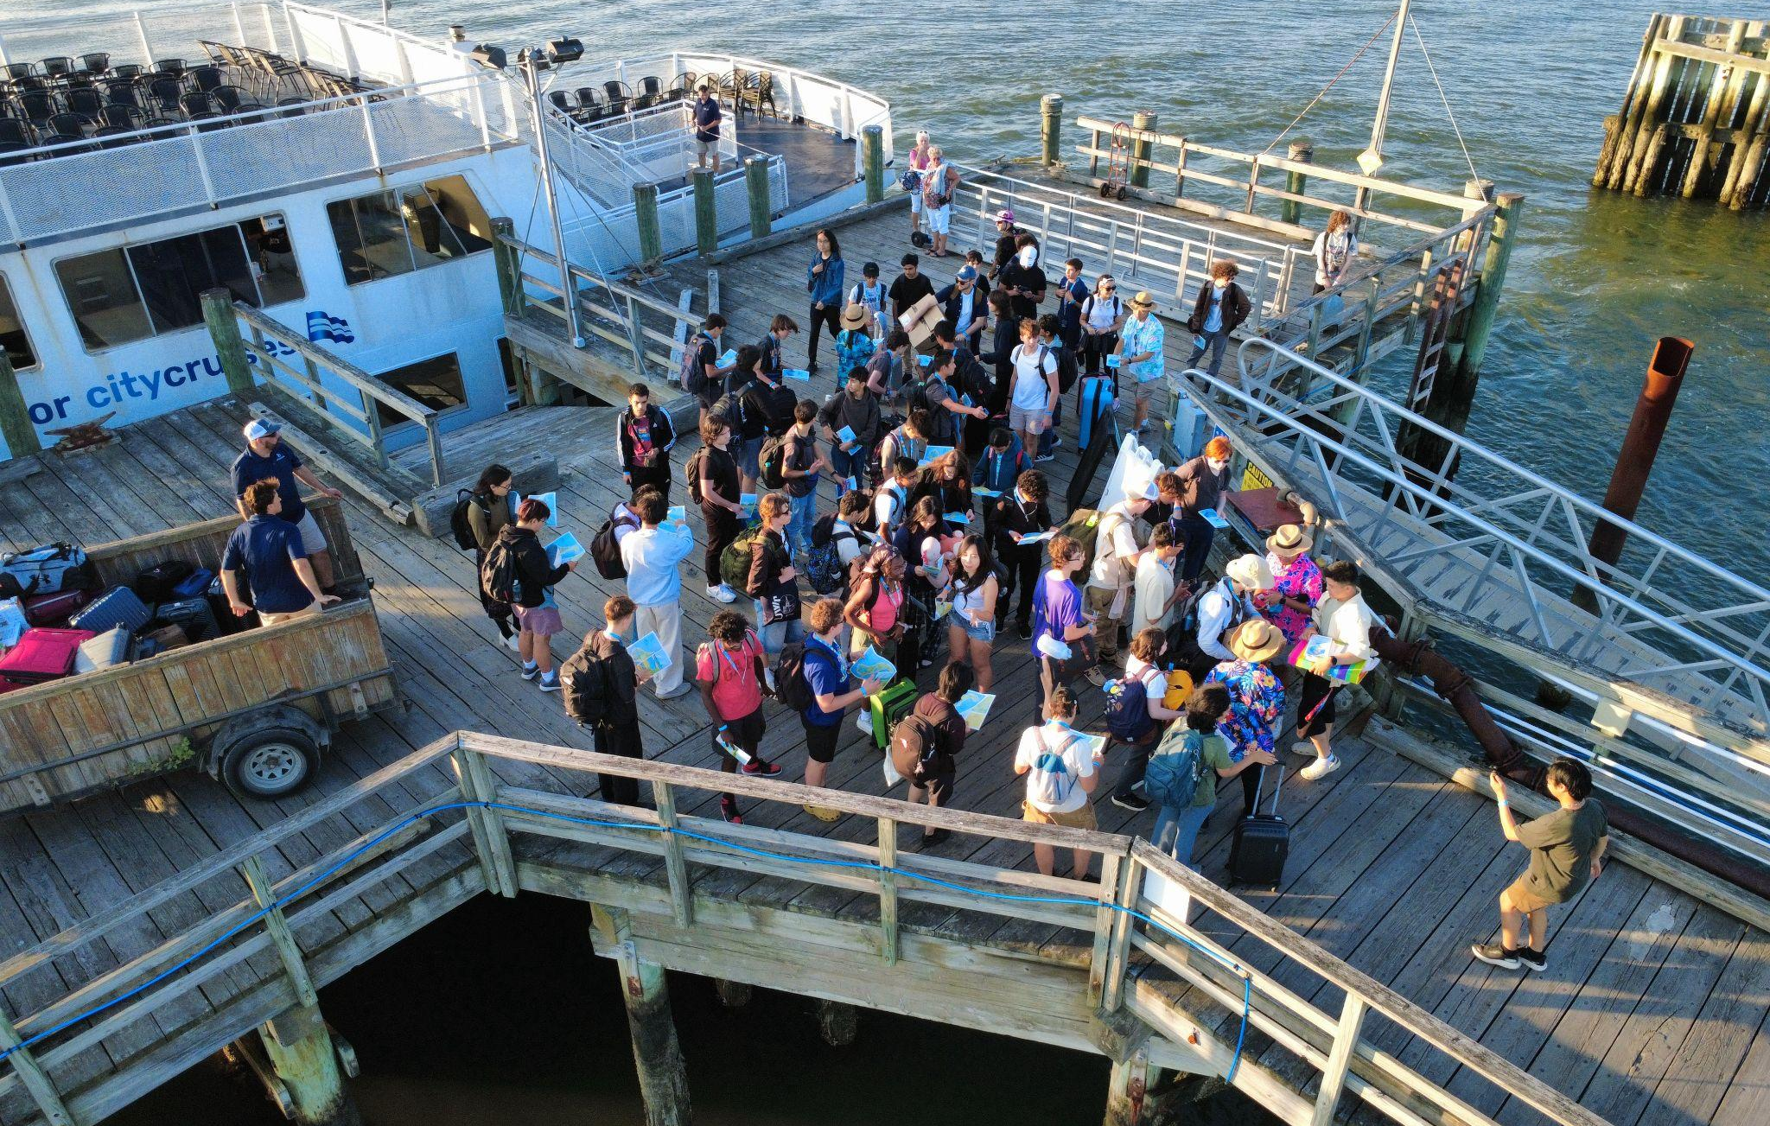  Shipwrecked, Boston

What is Haven?
November 14th to 15th, from [time to time], Haven [CITY] is happening at [Venue]. Your child will be coding a game from scratch in [12/24/two days].

Haven is a game jam, organized by students in your city along with adult chaperones! A game jam is a coding event where your child will code a game in 24 hours. Haven is happening in 200+ cities worldwide simultaneously this weekend. They will get to take part in a community of 100,000+ high school makers!

Expenses & Meals
Attending Haven [City] will be completely free for your child! This includes all necessities for the duration of the event, including food and drinks. We will also be providing meals and sleeping spaces for all attendees.

Traveling to [VENUE]
Please drop your child off at the venue [Address].
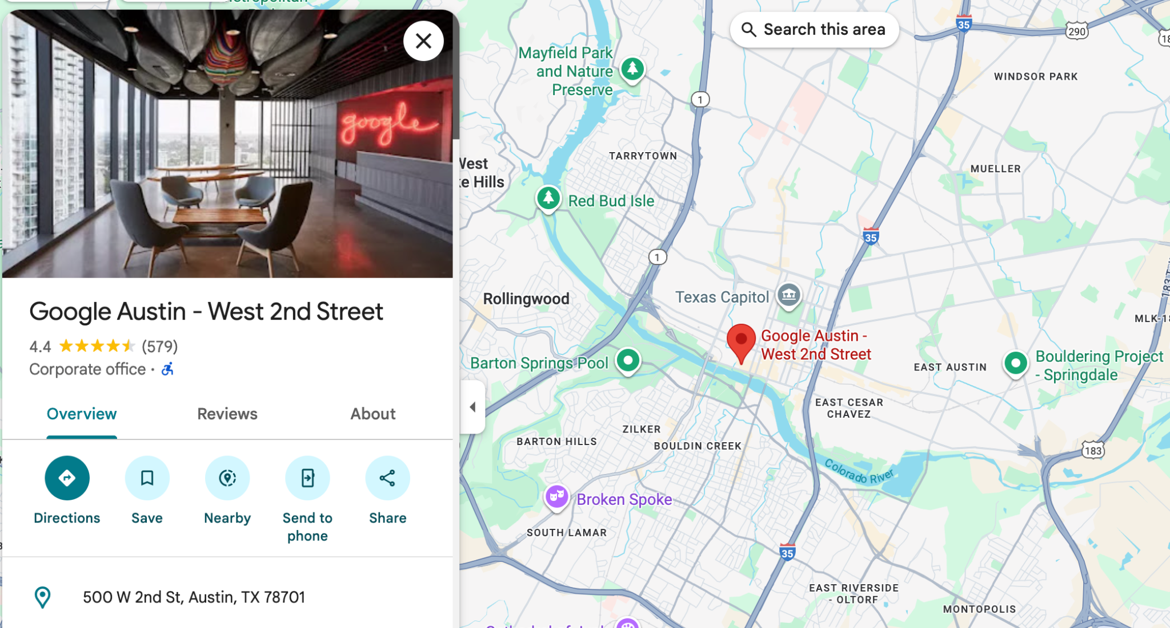
The event starts at [time] on Saturday, November 14th. Doors open at [time]. The event ends at [time] on Sunday, November 15th.

Safety Arrangements and Safeguarding
Haven is committed to creating a safe and comfortable environment for students at our events. We have dedicated safeguarding officers available at all times during the event

[ORGANIZERS- MAKE SURE THE FOLLOWING IS ACCURATE FOR YOUR EVENT]
The event will have 24/7 adult supervision and gender-separated sleeping areas. The venue is closed doors which means that only those that have registered will be allowed to enter the venue. Additionally, Hack Club has a zero-tolerance policy towards any drugs, alcohol, and any other forms of contraband.

You can read more about how we take care of participants in our safeguarding policy -> hackclub.com/safeguarding-policy

Key Personnel
[Add names and photos of your organizers]

Contact Information
You can call organizers at [phone_number] any time during, prior, or after the event to have your questions answered or learn about the event.

